[Electric Power Systems Research](http://www.sciencedirect.com/science/journal/03787796" \o "Go to Electric Power Systems Research on ScienceDirect)

[Volume 79, Issue 1](http://www.sciencedirect.com/science/journal/03787796/79/1), January 2009, Pages 134-143

[](http://www.sciencedirect.com/science/journal/03787796/79/1)

The impact of distributed synchronous generators on quality of electricity supply and transient stability of real distribution network

Author links open overlay panel[V.Calderaro](http://www.sciencedirect.com/science/article/pii/S0378779608001636" \l "!)[a](http://www.sciencedirect.com/science/article/pii/S0378779608001636" \l "!)[J.V.Milanovic](http://www.sciencedirect.com/science/article/pii/S0378779608001636" \l "!)[b](http://www.sciencedirect.com/science/article/pii/S0378779608001636" \l "!)[M.Kayikci](http://www.sciencedirect.com/science/article/pii/S0378779608001636" \l "!)[b](http://www.sciencedirect.com/science/article/pii/S0378779608001636" \l "!)[A.Piccolo](http://www.sciencedirect.com/science/article/pii/S0378779608001636" \l "!)[a](http://www.sciencedirect.com/science/article/pii/S0378779608001636" \l "!)

Show more

<https://doi.org/10.1016/j.epsr.2008.05.022>[Get rights and content](https://s100.copyright.com/AppDispatchServlet?publisherName=ELS&contentID=S0378779608001636&orderBeanReset=true)

Abstract

The paper investigates steady state and transient impact of Distributed Synchronous Generators (DSG) on a real Italian distribution network. Before connecting or allowing the connection of DSG, the worst operating scenarios have to be analyzed to guarantee that the network voltages remain within allowed ranges. A voltage profile variation and steady state voltage regulation are analyzed, therefore following connection of DSG. Transient analysis is also performed in order to analyze the impact of DSG on stability and protection system. Further, the islanding operating mode of the network is considered having in mind that the DSG could provide additional to the load in the absence of the main power supply. In particular, in the event of a supply outage, the temporary islanding operation of DSG might improve the continuity of service and such contribute to the overall quality of electricity supply to the customers.

* [**Previous**article](http://www.sciencedirect.com/science/article/pii/S0378779608001624)
* [**Next**article](http://www.sciencedirect.com/science/article/pii/S0378779608001648)

Keywords

Distributed generation

Distribution network

Transient analysis

Steady state analysis

1. Introduction

Over the last several years Distributed Generation (DG), integrated into distribution networks continued to grow both in number and size. Governments’ incentives and obligations for a sustainable energy ensure that DG is going to be an important element in the future distribution systems. Moreover, a large diffusion of DG is particularly encouraged by the difficulties in obtaining licenses for the expansion and reinforcement of the network to meet increasing load demand and by the liberalization and the introduction of competitive electric markets that had provided lucrative opportunities for independent power producers.

Nevertheless, at present, DG is seen almost exclusively as energy supply without other functions (voltage support, network reliability, generation reserve, etc.) and its potential benefits, both, for the whole system and independent power producers, are not taken into account. This restricted role of DG is due to several technical factors that thwart a more efficient development of the distribution systems in presence of distributed resources.

An important technical obstacle is the direction of the power flows. The conventional, radial, distribution networks are designed to ensure real power flows in one direction, from centralised generating units downward through the distribution feeder to the end users. In presence of DG, however, power flow may occur in an opposite direction. Thus, the net power flow is more unpredictable and it is difficult for the utilities to establish clearly the benefits derived from the connection of DG. The above stimulate individual studies for determining the exact impact of DG on distribution network in order to draw more benefits from its connection.

Several studies in the past investigated the impact of DG on operating conditions of the network and identified some critical aspects regarding their connection. In [[1]](http://www.sciencedirect.com/science/article/pii/S0378779608001636" \l "bib1) the role of DG as the equivalent of spinning support reserve or voltage support is verified. In [[2,3]](http://www.sciencedirect.com/science/article/pii/S0378779608001636" \l "bib2) the temporary grid-disconnected operation of autonomous part of the network including several type of DG is investigated. In [[2]](http://www.sciencedirect.com/science/article/pii/S0378779608001636#bib2) the analysis on the critical transients occurring at disconnection from and reclosure with main supply is conducted while in [[3]](http://www.sciencedirect.com/science/article/pii/S0378779608001636" \l "bib3) load shedding scheme and output power control of DG are considered to maintain stable operation of islanded power system. Among the numerous issues related to the operation of the networks with DG that require detailed investigation, the transient stability has been identified as one of the major [[4–8]](http://www.sciencedirect.com/science/article/pii/S0378779608001636" \l "bib4). In [[4]](http://www.sciencedirect.com/science/article/pii/S0378779608001636#bib4) the influence of Distributed Synchronous Generator (DSG) and Distributed Induction Generators (DIG) on stability of a generic distribution system is investigated while [[5]](http://www.sciencedirect.com/science/article/pii/S0378779608001636" \l "bib5) focused on dynamic behaviour of the network with high penetration of different DSGs. The [[6]](http://www.sciencedirect.com/science/article/pii/S0378779608001636" \l "bib6) investigated the transmission system transient stability when a fault is applied at all branches in order to analyze *N*-1 security and [[7]](http://www.sciencedirect.com/science/article/pii/S0378779608001636" \l "bib7) considered the stability of power system in the presence of large number of fuel cells and micro-turbines. A comparative study based on steady state and transient analysis of the network with DSG and DIG is presented in [[8]](http://www.sciencedirect.com/science/article/pii/S0378779608001636" \l "bib8). It is highlighted there that DSGs offer significant advantages with respect to steady state voltage profile, voltage stability and transient stability and permit higher penetration level of DG. On the other hand, studies [[9,10]](http://www.sciencedirect.com/science/article/pii/S0378779608001636" \l "bib9) showed that the increase in fault currents is often greater in case of DSG than in case of comparable inverter connected generators [[9]](http://www.sciencedirect.com/science/article/pii/S0378779608001636#bib9) or DIG which contribute to short-circuit current only for the short period of time immediately after the fault [[10]](http://www.sciencedirect.com/science/article/pii/S0378779608001636" \l "bib10). (*Note*: even though the inverter connected generators typically contribute low short-circuit currents to the network this should not prevent careful examination, revision and if necessary appropriate adjustment of existing protection schemes). This paper presents complete analysis, including steady state and transient studies, of the impact of DSG on a real radial distribution system located in Sicily. A realistic distribution network model with DSG equipped with suitable governor and Automatic Voltage Regulator (AVR) is considered, making it possible to operate in both grid connected and islanded mode and such offer greater continuity of service. (*Note*: one should be aware though, that in practice many issues limit or prevent islanded operation of the network such as personnel safety, difficulties in maintaining an acceptable power quality, risk to lose the synchronism, etc.).

As the considered DSG is directly connected to the network potentially greater fault currents may be expected. Therefore, considerations are also given to the suitability of existing Italian protection system for different DSG sizes. When the penetration of DSG is low, the impact of DG can be neglected while when it is high, the DSGs influence the whole system including protection system. Only three-phase faults are considered in this study as they result in the most challenging stability problems [[11]](http://www.sciencedirect.com/science/article/pii/S0378779608001636" \l "bib11) and the setting of the protection system becomes more critical in case of severe faults and significant fault current contributions from DSG [[9]](http://www.sciencedirect.com/science/article/pii/S0378779608001636#bib9). In particular, the choice to consider only three-phase faults arises from the premise that they determine the most critical conditions for the transient stability considering:

•

the loading of generators,

•

the output of generators during the fault that depends on the fault location and type (most severe for three-phase fault),

•

the fault clearing time,

•

the considered inertia and reactance of the generators.

The results obtained can be a useful technical guide for engineers and independent power producers to establish the worst case scenario that may result from connection of DSG to a typical Italian distribution network, or any network of similar structure, composition and protection system applied.

2. Distribution system description

In order to investigate the impact of DSG on power system steady state voltage profile and transient stability a real radial distribution network located in Sicily (Italy) is used. The single line diagram of the distribution system, without DSG, is presented in [Fig. 1](http://www.sciencedirect.com/science/article/pii/S0378779608001636" \l "fig1).

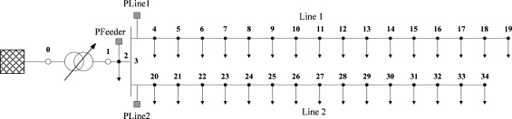

1. [Download full-size image](https://ars.els-cdn.com/content/image/1-s2.0-S0378779608001636-gr1.jpg)

Fig. 1. Real Italian distribution network.

The considered network consists of a 132 kV, 50 Hz sub-transmission system with short-circuit level of 1000 MV A which feeds a 20 kV distribution system through a 132/20 kV, *Δ*/*Y*gtransformer with rated power equal to *S*T = 35 MV A, *V*cc = 13.18% and *X*/*R* = 30.737. The primary substation transformer's tap is adjusted in order to maintain voltages at all buses within the allowable range for minimum and maximum demand without DSG. The OLTC parameters are given in [Table B1](http://www.sciencedirect.com/science/article/pii/S0378779608001636" \l "tbl6) in [Appendix B](http://www.sciencedirect.com/science/article/pii/S0378779608001636" \l "app1). The distribution network consists of 32 buses and more than 31 lines. A feeder, composed of two different materials, Al and Cu, starts from the secondary side of the primary substation HV/MV and feeds bus 3, a Satellite Centre (SC). From SC two principal lines, line 1 and line 2, supply the loads. Total network load (real power only) during maximum demand is 4.38 MW of which line 1 takes 3.29 MW, and line 2, 1.09 MW. During the minimum demand period, total load is 1.39 MW, of which line 1 carries 0.89 MW and line 2, 0.50 MW. The distribution lines and the feeder are modelled as series connection of resistance and inductance and the loads are represented by constant power model ([Tables B2–B3](http://www.sciencedirect.com/science/article/pii/S0378779608001636" \l "tbl7) in [Appendix B](http://www.sciencedirect.com/science/article/pii/S0378779608001636#app1)).

2.1. Synchronous generator

The distribution radial network includes one or more synchronous generators typically used by distribution systems if the generator capacity exceeds a few MW [[12]](http://www.sciencedirect.com/science/article/pii/S0378779608001636" \l "bib12). At present, most DG systems in Italy employ synchronous generators, which are used in thermal, hydro or wind power plants. Typically, synchronous generators are operated as constant power (real power) sources. In this study however, in order to investigate an islanded operation, a voltage control system is considered. Usually two modes are applied to control the excitation system of DSG [[13,14]](http://www.sciencedirect.com/science/article/pii/S0378779608001636" \l "bib13):

(i)

Voltage control mode, keeping constant the terminal voltage.

(ii)

Power factor control mode, aiming to keep constant power factor.

As the mode (ii) is used by independent power producers in order to maximize the generated active power, no consideration is given to potential support to the network voltages. In this study however, a voltage control mode, using an AVR, is adopted and the controller set point is fixed at 1 pu. The AVR block diagram is present in [Fig. 2](http://www.sciencedirect.com/science/article/pii/S0378779608001636" \l "fig2).

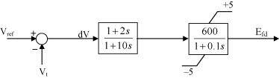

1. [Download full-size image](https://ars.els-cdn.com/content/image/1-s2.0-S0378779608001636-gr2.jpg)

Fig. 2. Automatic voltage regulator (simplified excitation system, IEEE type AC4A, with values taken from IEEE Std. 421.5-2005 and slightly modified to represent fast acting excitation system).

The synchronous generator is represented by a sixth-order model in the *d*–*q* reference frame. The generator is also equipped with a standard IEEE hydraulic turbine governor, for the completeness of dynamic model of the plant. The block diagram of the governor system is shown in [Fig. 3](http://www.sciencedirect.com/science/article/pii/S0378779608001636" \l "fig3).

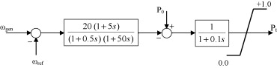

1. [Download full-size image](https://ars.els-cdn.com/content/image/1-s2.0-S0378779608001636-gr3.jpg)

Fig. 3. Governor model (IEEESGO, IEEE Standard Governor, with values chosen such that the governor response matches that of a hydro-generator).

The rated power of DSG is *S*n = 1.875 MV A and it operates with a lagging power factor cos *φ* = 0.8. Full details are given in [Table B4](http://www.sciencedirect.com/science/article/pii/S0378779608001636" \l "tbl9) in [Appendix B](http://www.sciencedirect.com/science/article/pii/S0378779608001636#app1).

2.2. Protection systems

The philosophy of the protection system of an Italian distribution network is suggested by the topology of the network itself. In operative condition it is radial and passive, so in order to clear polyphase faults it is enough to install coordinated overcurrent relays. As in this paper only polyphase faults are considered, the protection system against single-phase faults will not be presented. The protection relays of DSG and transformers will be also neglected in order to analyze dynamic interactions among DSG and the network in islanding conditions. If the protection relays of DSG and transformer had been considered, according to the Italian setting [[16,17]](http://www.sciencedirect.com/science/article/pii/S0378779608001636" \l "bib16), in case of a line fault, the islanding operating condition would be avoided since the protection system would disconnect the generators after the first reclosing of the protected line.

At present, overcurrent protection relays are set according to DK 4452 standard [[18]](http://www.sciencedirect.com/science/article/pii/S0378779608001636" \l "bib18). In particular, the standard distinguishes distribution system with or without SC. The relay setting in this paper is based on a real case characterized by the presence of SC at bus 3, as shown in [Fig. 1](http://www.sciencedirect.com/science/article/pii/S0378779608001636#fig1).

The management of the network suggested the installation of current direction insensitive relay, with three different current thresholds for the feeder (PFeeder), which feeds SC, and current insensitive relay with two different current thresholds for any line starting from the SC (PLine). While the PFeeder is characterized by two delayed current thresholds and one in time base, PLine has one delayed current threshold and one in time base [[18]](http://www.sciencedirect.com/science/article/pii/S0378779608001636#bib18).

Both protection systems are equipped with automatic recloser devices (DRA), which are characterized by two reclosing operations, one fast after 400 ms and one slow after 30 s. Time setting, current thresholds and reclosing time for the whole protection system are shown in [Figs. 4 and 5](http://www.sciencedirect.com/science/article/pii/S0378779608001636" \l "fig4). (*Note*: it should be emphasized that the protection system against polyphase faults and overloads is independent of the condition of the neutral wire. The neutral wire affects, essentially, the system behaviour against single-phase faults.)

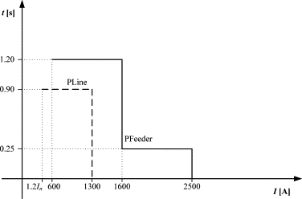

1. [Download full-size image](https://ars.els-cdn.com/content/image/1-s2.0-S0378779608001636-gr4.gif)

Fig. 4. Protection setting.

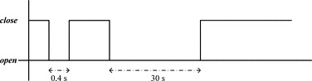

1. [Download full-size image](https://ars.els-cdn.com/content/image/1-s2.0-S0378779608001636-gr5.gif)

Fig. 5. Reclosing procedure.

3. Case studies

To illustrate the impact of DSG on a real distribution network, steady state voltage profile analysis and transient analysis have been performed. Several DSG penetration levels in the system with DSG at different locations have been analyzed for both, minimum and maximum demand periods.

The scenarios considered are shown in [Table 1](http://www.sciencedirect.com/science/article/pii/S0378779608001636" \l "tbl1).

Table 1. Penetration scenarios of DSG

| **Case** | **Penetration level (% maximum load)** | **Position DSG** |
| --- | --- | --- |
| a | No generation | – |
| b | 30 | 11 |
| c | 100 | 11 |
| d | 100 | 19 |
| e | 30 | 27 |
| f | 100 | 27 |
| g | 30 | 34 |
| h | 100 | 20 |
| i | 100 | 4 |

In all cases, except cases (h) and (i), steady state voltage profiles have been evaluated using a load flow Newton-Raphson procedure, modelling the loads as *P*, *Q* bus, DSG as *P*, *V* bus with limits on reactive power, transmission network as slack bus and considering [[8]](http://www.sciencedirect.com/science/article/pii/S0378779608001636#bib8):

(i)

Steady state voltage variation due to generator disconnection.

(ii)

Steady state voltage regulation.

Transient analysis was performed in all cases considering:

(i)

Three-phase permanent fault on the feeder without reclosing.

(ii)

Three-phase temporary fault on the feeder without reclosing.

(iii)

Three-phase temporary fault on the feeder with reclosing.

The simulations are performed using DIgSILENT PowerFactory 13.1 (B260). Maximum and minimum demand profiles used in simulations are obtained from measurements in considered distribution network. Dynamic behaviour of loads is not considered in order to highlight and separate the influence of DSG, otherwise the responses would be a mixture of generator and load dynamics and very difficult to separate. The static, constant power load model is considered instead as it is proven to be the least flexible to voltage variations and therefore most detrimental to network and system operation.

4. Steady state voltage profile

One of the main advantages of employing DSG is an improvement of the overall steady state voltage profile of the network. Nevertheless, voltage violations due to the presence of DSG can occur and considerably limit the amount of power supplied by these generators in distribution system. Before installing or allowing the installation of a DSG, Distribution Network Operator (DNO) must verify that in the worst operating scenarios the network voltage profile will not be adversely affected by the generators. The considered steady state voltage variation is 5% (pu).

The steady state voltage profiles considering maximum demand and all cases for DSG location and size are shown in [Fig. 6](http://www.sciencedirect.com/science/article/pii/S0378779608001636" \l "fig6), while the network voltage profiles for minimum demand and for all DSG cases are presented in [Fig. 7](http://www.sciencedirect.com/science/article/pii/S0378779608001636" \l "fig7).

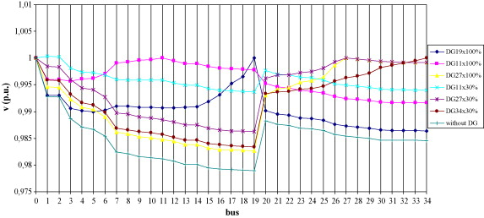

1. [Download full-size image](https://ars.els-cdn.com/content/image/1-s2.0-S0378779608001636-gr6.jpg)

Fig. 6. Voltage profiles with maximum demand.

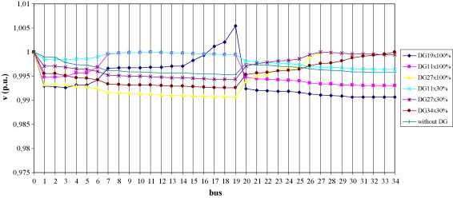

1. [Download full-size image](https://ars.els-cdn.com/content/image/1-s2.0-S0378779608001636-gr7.jpg)

Fig. 7. Voltage profiles with minimum demand.

With a constant voltage at DSG bus for both cases (maximum and minimum demand) voltage at all buses remains within the allowable range. The maximum variation of 1.7% is obtained in case of DSG at bus 27 with a penetration level equal to 100%. A critical case for a maximum demand scenario is obtained with DSG penetration level equal to 30% with DSG at bus 11. In this case DSG could not keep the voltage at 1 pu. because it reached its reactive power limit of 1.875 MVar.

Regarding minimum demand cases, it can be seen that the voltage level at bus 19, with a penetration level of 100% at the same bus, exceeds 1 pu. as the DSG reaches its reactive power limit.

In all simulated cases, both active and reactive power demands of the loads are kept constant. Thus, the power required from transmission network decreases with the increase of DSG penetration level.

Distribution Network Operators (DNO) are generally worried if DSG gets suddenly disconnected because the actuation time of voltage controller in distribution system is slow and DNOs have to guarantee that such variations are as small as possible. In order to analyze this aspect the index defined by Eq. [(1)](http://www.sciencedirect.com/science/article/pii/S0378779608001636" \l "eq1) is introduced [[8]](http://www.sciencedirect.com/science/article/pii/S0378779608001636#bib8).

(1)VI1=1nb∑i=1nbVig−Vin×100∑i=1nbVin

[Table 2](http://www.sciencedirect.com/science/article/pii/S0378779608001636" \l "tbl2) presents the results obtained for all locations and sizes of DSG. It can be sent from the table that the larger voltage variations are obtained with maximum load demand, even if they are very small. It can be further noticed that with a 100% penetration level at bus 27 and with 30% penetration level at bus 34, the voltage variation index *V*I1 is the same for maximum demand. From the results presented in [Table 2](http://www.sciencedirect.com/science/article/pii/S0378779608001636#tbl2) it looks that the line 2 is not sensitive to penetration of DSG equipped with an AVR.

Table 2. Voltage variation due to disconnection of DSG

| **DSG (% load)** | **DSG bus position** | ***V*I1 minimum load** | ***V*I1 maximum load** |
| --- | --- | --- | --- |
| 100 | 19 | 0.012 | 0.016 |
| 100 | 11 | 0.009 | 0.032 |
| 100 | 27 | 0.010 | 0.020 |
| 30 | 34 | 0.007 | 0.020 |
| 30 | 11 | 0.005 | 0.032 |
| 30 | 27 | 0.005 | 0.027 |

Even if DSG is connected to the network and it injects significant amount of reactive power to support voltages, large variation of voltages are not evident. So an impact of other types of generators or controls (DIG or DSG with constant power factor) should have negligible impacts on the steady state voltage profiles as well [[8]](http://www.sciencedirect.com/science/article/pii/S0378779608001636#bib8).

The last analyzed parameter is related to changes in voltage magnitudes between maximum and minimum demand because it is desirable to have those changes as small as possible following load variations. The index [[8]](http://www.sciencedirect.com/science/article/pii/S0378779608001636#bib8) used for this purpose is given by Eq. [(2)](http://www.sciencedirect.com/science/article/pii/S0378779608001636" \l "eq2).

(2)VI2=1nb∑i=1nbVimax−Vimin×100

[Table 3](http://www.sciencedirect.com/science/article/pii/S0378779608001636" \l "tbl3) presents the results of this analysis.

Table 3. Voltage regulation

| **DSG (% of load)** | **DSG bus position** | ***V*I2** |
| --- | --- | --- |
| 100 | 19 | 0.41 |
| 100 | 11 | 0.08 |
| 100 | 27 | 0.31 |
| 30 | 34 | 0.39 |
| 30 | 11 | 0.28 |
| 30 | 27 | 0.31 |

It can be seen that a penetration level of 100% and DSG at bus 11 lead to the best voltage regulation. With DSG at bus 27, the voltage regulation is not sensitive to the size of the generator (penetration level).

5. Transient stability

In Italy, if a fault occurs on distribution network, DG trips and does not generate power until critical network conditions are removed. So, the control scheme of DG will wait to be restored and restart automatically. In this sense, as the objective of DG is to generate power, considerations about transient stability tend not to be of great significance.

Nevertheless, if DG is intended as a voltage support for critical processes then more care is required to try to ensure that DG does not trip for remote network faults. However, as the inertia constant of DG is often low and the tripping time of protection system long, it may not be possible to ensure stability for all faults in the distribution network and transient stability becomes considerably important [[13]](http://www.sciencedirect.com/science/article/pii/S0378779608001636#bib13).

In this study load flows are firstly performed to establish the pre-fault network conditions. Transient simulations are then performed to investigate the distribution system stability when a fault occurs on the feeder of the distribution network in [Fig. 1](http://www.sciencedirect.com/science/article/pii/S0378779608001636#fig1). Since during short-circuits DSG accelerates, it may become unstable due to loss of synchronism. The stability of DSG can be determined by analysing the dynamic response of the rotor angle [[15,19]](http://www.sciencedirect.com/science/article/pii/S0378779608001636" \l "bib15). Time domain simulations are used to assess the impact of DSG penetration level on transient stability. Considered indicator to evaluate transient stability is the angle between the DSG connected to the network and the reference machine angle corresponding to the infinite bus.

The transient analysis investigates responses for both, a permanent three-phase fault and a 100 ms self-clearing three-phase fault. The implemented protection system is shown in Section [3](http://www.sciencedirect.com/science/article/pii/S0378779608001636" \l "sec1). Due to the space limitation only a few characteristic cases are presented in detail. The results for all other cases are summarized in a table considering the following parameters: transient stability, re-synchronization for temporary fault with or without reclosing, behaviour of the protection system, islanding mode.

The following analysis considers the cases described in Section [5](http://www.sciencedirect.com/science/article/pii/S0378779608001636" \l "sec2).

*Case d1*: DSG at bus 19, power output *P* = 4.5 MW, permanent fault with maximum demand.

[Fig. 8](http://www.sciencedirect.com/science/article/pii/S0378779608001636" \l "fig8) presents dynamics responses of DSG for a three-phase permanent fault applied in the middle of the feeder connecting buses 2 and 3, when DSG is injecting 4.5 MW into distribution network.

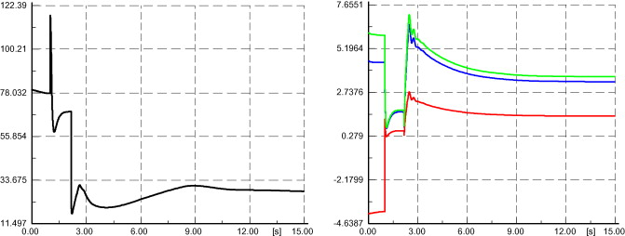

1. [Download full-size image](https://ars.els-cdn.com/content/image/1-s2.0-S0378779608001636-gr8.jpg)

Fig. 8. Case d1, rotor angle, real (*b*), reactive (*r*), and apparent power (*g*).

It can be seen that the stability is regained after few seconds (450 cycles) and that the AVR maintains the voltage at 1 pu. The distribution system operates in an islanded mode as the DSG continues to supply the line 1 after the tripping of the feeder and the line 1 protections.

[Fig. 9](http://www.sciencedirect.com/science/article/pii/S0378779608001636" \l "fig9) shows the voltage at the beginning (bus 4) and at the end (bus 19) of the line 1. Excluding the fault period, the voltage is sustained by the DSG.

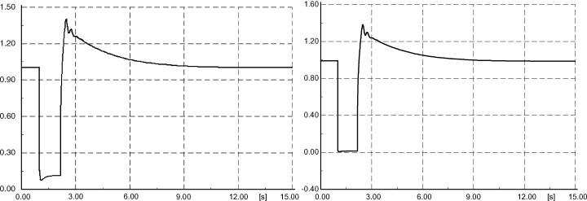

1. [Download full-size image](https://ars.els-cdn.com/content/image/1-s2.0-S0378779608001636-gr9.jpg)

Fig. 9. Case d1, voltage at bus 19 (left) and 4 (right).

*Cases d2 and d3*: DSG at bus 19, power output *P* = 4.5 MW, temporary fault without and with reclosing, with maximum demand.

For the same DSG location and size, the simulation is repeated but with a self-clearing fault without and with reclosing, respectively.

In the case without reclosing, the stability is regained and an island is formed by line 1 and line 2. The power and the rotor angle variations are presented in [Fig. 10](http://www.sciencedirect.com/science/article/pii/S0378779608001636" \l "fig10) while [Fig. 11](http://www.sciencedirect.com/science/article/pii/S0378779608001636" \l "fig11) shows voltages at the boundary bus of the line 1.

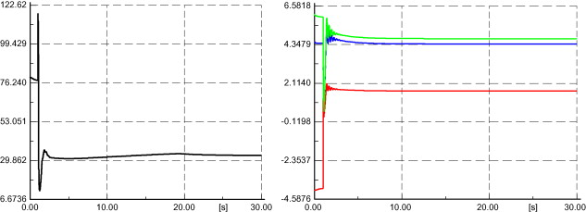

1. [Download full-size image](https://ars.els-cdn.com/content/image/1-s2.0-S0378779608001636-gr10.jpg)

Fig. 10. Case d2, rotor angle, real (*b*), reactive (*r*), and apparent power (*g*).

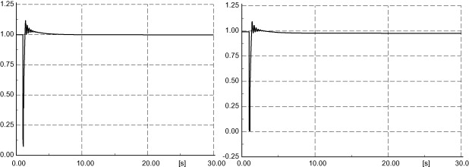

1. [Download full-size image](https://ars.els-cdn.com/content/image/1-s2.0-S0378779608001636-gr11.jpg)

Fig. 11. Case d2, voltage at bus 19 (left) and 4 (right).

Considering the same case with reclosing it can be seen that the network maintains its original structure without synchronization problems after the reclosing. At the instant of fault only the feeder protection trips and as the fault is self-clearing the reclosing procedure is activated only from the feeder protection. The rotor angle and the power variations are shown in [Fig. 12](http://www.sciencedirect.com/science/article/pii/S0378779608001636" \l "fig12).

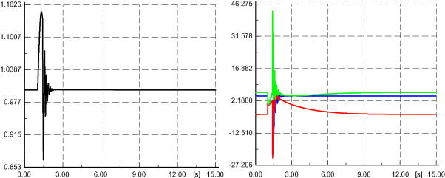

1. [Download full-size image](https://ars.els-cdn.com/content/image/1-s2.0-S0378779608001636-gr12.jpg)

Fig. 12. Case d3, rotor angle, real (*b*), reactive (*r*), and apparent power (*g*).

*Case e2*: DSG at bus 27, power output *P* = 1.5 MW, self-clearing fault with maximum demand.

The system lost stability in case of temporary fault without reclosing. [Fig. 13](http://www.sciencedirect.com/science/article/pii/S0378779608001636" \l "fig13) illustrates the voltage collapse at bus 27 after the fault clearing.

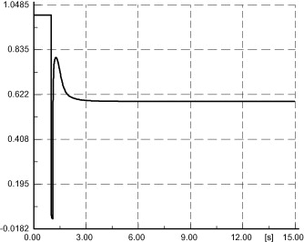

1. [Download full-size image](https://ars.els-cdn.com/content/image/1-s2.0-S0378779608001636-gr13.jpg)

Fig. 13. Case e2, voltage at the bus 27.

From [Tables 4 and 5](http://www.sciencedirect.com/science/article/pii/S0378779608001636" \l "tbl4) it can be seen that, for the same analyzed cases with maximum demand, the stability can be recovered in cases of minimum demand with DSG at bus 11, 27 and 34, with a penetration level of 30% of the maximum demand.

Table 4. Simulation results for transient analysis with maximum demand

| **DSG position** | **DSG size (% of maximum load)** | **Three-phase fault** | **Reclose** | **Fault position** | **Trip protection** | **Stability** | **Island** | **Synch.** |
| --- | --- | --- | --- | --- | --- | --- | --- | --- |
| 19 | 100 | Permanent | N | Feeder | F&PL1 | Y | Line 1 | – |
| 19 | 100 | Temporary | N | Feeder | F | Y | Network | Y |
| 19 | 100 | Temporary | Y | Feeder | (F) | Y | N | Y |
| 11 | 30 | Permanent | N | Feeder | F | N | N | – |
| 11 | 30 | Temporary | N | Feeder | F | N | N | – |
| 11 | 30 | Temporary | Y | Feeder | (F) | Y | N | Y |
| 27 | 30 | Permanent | N | Feeder | F | N | N | – |
| 27 | 30 | Temporary | N | Feeder | F | N | N | – |
| 27 | 30 | Temporary | Y | Feeder | (F) | Y | N | Y |
| 34 | 30 | Permanent | N | Feeder | F | N | N | – |
| 34 | 30 | Temporary | N | Feeder | F | N | N | – |
| 34 | 30 | Temporary | Y | Feeder | (F) | Y | N | Y |
| 11 | 100 | Permanent | N | Feeder | F&PL1 | Y | Line 1 | – |
| 11 | 100 | Temporary | N | Feeder | F | Y | Network | Y |
| 11 | 100 | Temporary | Y | Feeder | (F) | Y | N | Y |
| 27 | 100 | Permanent | N | Feeder | F&PL2 | Y | Line 2 | – |
| 27 | 100 | Temporary | N | Feeder | F | Y | Network | Y |
| 27 | 100 | Temporary | Y | Feeder | (F&PL2) | Y | N | Y/P |
| 4 | 100 | Permanent | N | Feeder | F&PL1 | Y | Line 1 | – |
| 4 | 100 | Temporary | N | Feeder | F | Y | Network | Y |
| 4 | 100 | Temporary | Y | Feeder | (F&PL1) | Y | N | Y/P |
| 20 | 100 | Permanent | N | Line 1 (B2) | F&PL1 | Y | Line 2 | – |
| 20 | 100 | Permanent | N | Line 1 (B16) | F&PL1 | Y | Line 2 | – |
| 4 | 100 | Permanent | N | Line 2 (B18) | F&PL1 | Y | Line 1 | – |

Table 5. Simulation results for transient analysis with minimum demand

| **DSG position** | **DSG size (% of maximum load)** | **Three-phase fault** | **Reclose** | **Fault position** | **Trip protection** | **Stability** | **Island** | **Synch.** |
| --- | --- | --- | --- | --- | --- | --- | --- | --- |
| 11 | 30 | Permanent | N | Feeder | F | N | N | – |
| 11 | 30 | Temporary | N | Feeder | F | Y | Network | Y |
| 27 | 30 | Permanent | N | Feeder | F | N | N | – |
| 27 | 30 | Temporary | N | Feeder | F | Y | Network | Y |
| 34 | 30 | Permanent | N | Feeder | F | N | N | – |
| 34 | 30 | Temporary | N | Feeder | F | Y | N | – |

In case of a permanent fault with DSG at bus 11 other strategies have been considered in order to recover stability. A load shedding strategy was successfully implemented with DSG at bus 11 with 1.5 MW power output and with a permanent fault. The applied algorithm for load shedding is based on disconnection of loads after the slow reclosing action (30 s) of the protection system. Small loads are disconnected until the total real power of the connected loads falls below the power generated by DSG. In [Fig. 14](http://www.sciencedirect.com/science/article/pii/S0378779608001636" \l "fig14) power and rotor angle responses are shown. The spikes in rotor angle responses correspond to reclosing instants.

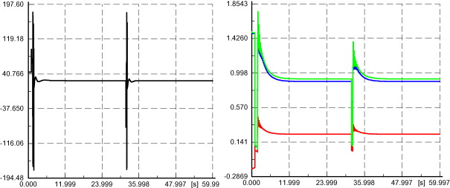

1. [Download full-size image](https://ars.els-cdn.com/content/image/1-s2.0-S0378779608001636-gr14.jpg)

Fig. 14. Load shedding case, rotor angle, real (*b*), reactive (*r*), and apparent power (*g*).

5.1. Protection system behaviour during transients

The considered protection system was designed assuming radial nature of the system without bidirectional power flow. Since the presence of DSG changes the direction of power flow one would assume that the protection system should be replaced by appropriate directional devices. In order to assess the behaviour of the relays during faults in the presence of DSG, the critical cases (h) and (i) have been considered. In published literature, the attention was mainly paid to those cases because if the fault occurs on the line without DSG, the protection of the line with DSG could trip and such put out of service all loads connected to the line [[20]](http://www.sciencedirect.com/science/article/pii/S0378779608001636" \l "bib20). This scenario is illustrated in [Fig. 15](http://www.sciencedirect.com/science/article/pii/S0378779608001636" \l "fig15).

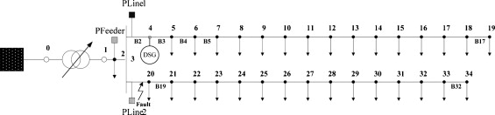

1. [Download full-size image](https://ars.els-cdn.com/content/image/1-s2.0-S0378779608001636-gr15.jpg)

Fig. 15. Critical case for protection system.

It can be seen from the results of simulation (summarized in the last case reported in [Table 4](http://www.sciencedirect.com/science/article/pii/S0378779608001636#tbl4)) that even if the relays insensitive to current direction are used in the network and protection system trips incorrectly following the fault, after the opening of PFeeder and PLine1 for a fault at the bus B18, the line 1 continues to operate correctly in islanded mode and the loads are supplied by DSG without causing any stability problem to the network. [Fig. 16](http://www.sciencedirect.com/science/article/pii/S0378779608001636" \l "fig16)illustrates corresponding rotor angle response. It can be concluded that even though the presence of DSG may guarantee continuity of supply in the islanded mode, the protection settings must be revised to avoid unpredictable behaviour of the connected relays. A solution could be to substitute relays insensitive to current direction by sensitive ones.

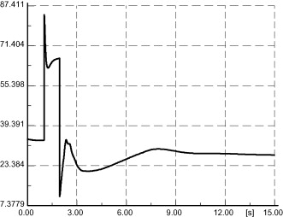

1. [Download full-size image](https://ars.els-cdn.com/content/image/1-s2.0-S0378779608001636-gr16.jpg)

Fig. 16. Case i1, rotor angle in islanding mode.

6. Conclusions

The paper presented steady state and transient analysis of real Italian distribution network with an embedded synchronous generator.

Steady state voltage variation following the disconnection of DSG and steady state voltage regulation, considering maximum and minimum demands, have been analyzed.

Considering steady state voltage profiles, it is found that the connection of DSG did not modify the behaviour and the performance of the system. Transient analysis however, showed that the DSG influences transient stability and protection system operation.

Even though in several cases the DSG maintained stability following the faults and offered a lot of benefits to the network by providing real power to the loads and reactive power to support the voltages in the network, there have been also several cases when it lost stability. A very few identified cases of instability demonstrated that by and large this particular real distribution network can accommodate DSGs. (*Note*: one should be aware though that the DSGs with smaller inertia tend to lose stability more easily.)

It should be pointed out though that some modifications of protection systems are necessary due to the increased fault currents resulting from the DSG. The reinforcement of the network is also needed in order to withstand the additional fault levels due to the proximity of the generator to the point of fault.

Finally, the feasibility of temporary islanded operation of the part of the distribution network with DSG was also analyzed. It was found that only a few cases presented synchronization (stability) problems. These, however, could be successfully resolved with appropriate load shedding strategies as demonstrated in the paper. By performing suitable, moderate, load shedding, the islanded system can be safely operated offering better continuity of supply to majority of customers.

The results of solutions are strictly valid for distribution networks with topological structure similar to Italian distribution grids. In fact, a typical Italian distribution network has been considered in the paper with a complete set of a typical protection system: line protections with recloser, feeder protection and SC. So, even though, the particular results might not be general they can be still used to deduce important conclusions about the strength of distribution networks of similar structure and protection practices applied.

Appendix A. List of symbols

*n*b

number of the buses.

*p*o

reference power load.

*V*f

bias signal.

*V*r

voltage at the generator terminal.

*V*ref

reference voltage set for initial DSG voltage terminal.

Vig

voltage magnitude at the *i*-bus in presence of DSG.

Vimax

maximum voltage during maximum demand period.

Vimin

minimum voltage during minimum demand period.

Vin

voltage magnitude at the *i*-bus in absence of DSG.

Appendix B.

In column 6 of [Tables 4 and 5](http://www.sciencedirect.com/science/article/pii/S0378779608001636#tbl4), “Trip protection”, F denotes feeder protection while PL1 denotes line 1 protection; the letter in the brackets denotes cases when corresponding protection is tripped and then the breaker is reclosed.

Table B1. Transformer parameters

|  |  |
| --- | --- |
| *S* | 35 MV A |
| HV/LV | 132 kV/20 kV |
| Short-circuit voltage | 13.18% |
| Copper losses | 150 kW |
| No load losses | 20 kW |
| Connection | YNd1 |

Table B2. Line data

| **From bus** | **To bus** | ***r* (Ω)** | ***x* (Ω)** |
| --- | --- | --- | --- |
| 1 | 2 | 0.3492 | 0.2034 |
| 2 | 3 | 0.5572 | 0.3246 |
| 3 | 4 | 0.1614 | 0.0602 |
| 4 | 5 | 0.0424 | 0.0282 |
| 5 | 6 | 0.1515 | 0.0352 |
| 6 | 7 | 0.2861 | 0.0754 |
| 7 | 8 | 0.0374 | 0.0193 |
| 8 | 9 | 0.0683 | 0.0398 |
| 9 | 10 | 0.0296 | 0.0196 |
| 10 | 11 | 0.0463 | 0.0307 |
| 11 | 12 | 0.0868 | 0.0576 |
| 12 | 13 | 0.1962 | 0.0998 |
| 13 | 14 | 0.0064 | 0.0026 |
| 14 | 15 | 0.2288 | 0.0915 |
| 15 | 16 | 0.1984 | 0.0794 |
| 16 | 17 | 0.4847 | 0.1304 |
| 17 | 18 | 0.2026 | 0.0652 |
| 18 | 19 | 0.4071 | 0.0739 |
| 3 | 20 | 0.0020 | 0.0007 |
| 20 | 21 | 0.2432 | 0.0973 |
| 21 | 22 | 0.0739 | 0.0276 |
| 22 | 23 | 0.1750 | 0.0652 |
| 23 | 24 | 0.0584 | 0.0218 |
| 24 | 25 | 0.1544 | 0.1024 |
| 25 | 26 | 0.4000 | 0.1600 |
| 26 | 27 | 0.1848 | 0.0800 |
| 27 | 28 | 0.1062 | 0.0704 |
| 28 | 29 | 0.1980 | 0.0773 |
| 29 | 30 | 0.2834 | 0.1128 |
| 30 | 31 | 0.1152 | 0.0454 |
| 31 | 32 | 0.1280 | 0.0512 |
| 32 | 33 | 0.0895 | 0.0334 |
| 33 | 34 | 0.1293 | 0.0517 |

Table B3. Bus data

| **Bus** | ***P*max load (MW)** | ***Q*max load (MW)** | ***P*min load (MW)** | **Qmin load (MW)** |
| --- | --- | --- | --- | --- |
| 1 | 0 | 0 | 0 | 0 |
| 2 | 0 | 0 | 0 | 0 |
| 3 | 0 | 0 | 0 | 0 |
| 4 | 0.45 | 0.22 | 0.12 | 0.06 |
| 5 | 0.30 | 0.15 | 0.04 | 0.02 |
| 6 | 0.02 | 0.01 | 0.01 | 0.00 |
| 7 | 0.06 | 0.03 | 0.03 | 0.01 |
| 8 | 0.06 | 0.03 | 0.04 | 0.02 |
| 9 | 0.17 | 0.08 | 0.05 | 0.02 |
| 10 | 0.26 | 0.12 | 0.06 | 0.03 |
| 11 | 0.28 | 0.14 | 0.06 | 0.03 |
| 12 | 0.48 | 0.23 | 0.23 | 0.11 |
| 13 | 0.23 | 0.11 | 0.03 | 0.01 |
| 14 | 0.07 | 0.03 | 0.02 | 0.01 |
| 15 | 0.41 | 0.20 | 0.08 | 0.04 |
| 16 | 0.27 | 0.13 | 0.03 | 0.01 |
| 17 | 0.02 | 0.01 | 0.01 | 0.00 |
| 18 | 0.06 | 0.03 | 0.03 | 0.01 |
| 19 | 0.11 | 0.05 | 0.04 | 0.02 |
| 20 | 0.06 | 0.03 | 0.02 | 0.01 |
| 21 | 0.03 | 0.03 | 0.01 | 0.00 |
| 22 | 0.09 | 0.03 | 0.02 | 0.01 |
| 23 | 0.09 | 0.05 | 0.04 | 0.02 |
| 24 | 0.05 | 0.04 | 0.02 | 0.01 |
| 25 | 0.09 | 0.03 | 0.03 | 0.01 |
| 26 | 0.09 | 0.04 | 0.03 | 0.01 |
| 27 | 0.08 | 0.04 | 0.03 | 0.01 |
| 28 | 0.08 | 0.04 | 0.04 | 0.02 |
| 29 | 0.06 | 0.04 | 0.03 | 0.01 |
| 30 | 0.09 | 0.03 | 0.05 | 0.02 |
| 31 | 0.09 | 0.04 | 0.05 | 0.02 |
| 32 | 0.05 | 0.04 | 0.03 | 0.01 |
| 33 | 0.06 | 0.02 | 0.03 | 0.01 |
| 34 | 0.05 | 0.03 | 0.04 | 0.02 |

Table B4. Generator parameters

|  |  |
| --- | --- |
| *S* | 1.875 MV A |
| *V*n | 20 kV |
| *P*n | 1.5 MW |
| *Q*max; *Q*min | 1.875 MVar; −1.875 MVar |
| Power factor | 0.8 |
| *x*d | 1.85 pu |
| *x*q | 1.11 pu |
| Inertia time constant | 0.404 s |
| Subtransient reactance | xd″ = 0.161 pu; xq″ = 0.209 pu |
| Transient reactance | xd′ = 0.277 pu; xq′ = 0.11 pu |

References

[[1]](http://www.sciencedirect.com/science/article/pii/S0378779608001636#bbib1)

G. Joos, B.T. Ooi, D. McGillis, F.D. Galiana, R. Marceau**The potential of distributed generation to provide ancillary services**

Power Engineering Society Summer Meeting, IEEE, vol. 3, July 16–20(2000), pp. 1762-1767

[[2]](http://www.sciencedirect.com/science/article/pii/S0378779608001636#bbib2)

R. Caldon, F. Rossetto, R. Turri**Temporary islanded operation of dispersed generation on distribution networks**

Universities Power Engineering Conference, UPEC, 39th International, vol. 3, September 6–8 (2004), pp. 987-991

[[3]](http://www.sciencedirect.com/science/article/pii/S0378779608001636#bbib3)

H. Cheng-Ting, C. Chao-Shun**Islanding operations for the distribution systems with dispersed generation systems**

Power Engineering Society General Meeting, IEEE, vol. 3, June 12–16(2005), pp. 2962-2968

[[4]](http://www.sciencedirect.com/science/article/pii/S0378779608001636#bbib4)

J.V. Milanovic, T.A. David**Stability of distribution networks with embedded generators and induction motors**

Power Engineering Society Winter Meeting, IEEE, vol. 2, January 27–31(2002), pp. 1023-1028

[[5]](http://www.sciencedirect.com/science/article/pii/S0378779608001636#bbib5)

J.G. Slootweg, W.L. Kling**Impacts of distributed generation on power system transient stability**

Power Engineering Society Summer Meeting, IEEE, vol. 2 (2002), pp. 862-867

[[6]](http://www.sciencedirect.com/science/article/pii/S0378779608001636#bbib6)

M. Reza, P.H. Schavemaker, J.G. Slootweg, W.L. Kling, L. van der Sluis**Impacts of distributed generation penetration levels on power systems transient stability**

Power Engineering Society General Meeting, IEEE, June 6–10 (2004), pp. 2150-2155

[[7]](http://www.sciencedirect.com/science/article/pii/S0378779608001636#bbib7)

A.M. Azmy, I. Erlich**Impact of distributed generation on the stability of electrical power system**

Power Engineering Society General Meeting, IEEE, vol. 2, June 12–16(2005), pp. 1056-1063

[[8]](http://www.sciencedirect.com/science/article/pii/S0378779608001636#bbib8)

W. Freitas, J.C.M. Vieira, A. Morelato, L.C.P. da Silva, V.F. da Costa, F.A.B.Lemos**Comparative analysis between synchronous and induction machines for distributed generation applications**

Power Systems IEEE Transactions, 21 (February (1)) (2006), pp. 301-311

[CrossRef](https://doi.org/10.1109/TPWRS.2005.860931)[View Record in Scopus](https://www.scopus.com/inward/record.url?eid=2-s2.0-32144458236&partnerID=10&rel=R3.0.0)

[[9]](http://www.sciencedirect.com/science/article/pii/S0378779608001636#bbib9)

A. Agustoni, M. Brenna, R. Faranda, E. Tironi, C. Pincella, G. Simioli**Constraints for the interconnection of distributed generation in radial distribution systems**

Proceedings of the 10th International Conference on Harmonics and Quality of Power (2002)

[[10]](http://www.sciencedirect.com/science/article/pii/S0378779608001636#bbib10)

N. Nimpitiwan, G.T. Heydt, R. Ayyanar, S. Suryanarayanan**Fault current contribution from synchronous machine and inverter based distributed generators**

Power Delivery, IEEE Transactions, 22 (January (1)) (2007), pp. 634-641

[CrossRef](https://doi.org/10.1109/TPWRD.2006.881440)[View Record in Scopus](https://www.scopus.com/inward/record.url?eid=2-s2.0-34147152764&partnerID=10&rel=R3.0.0)

[[11]](http://www.sciencedirect.com/science/article/pii/S0378779608001636#bbib11)

R. Marconato, Sistemi elettrici di Potenza, vol. 2, Ed. CLUP Milano, 1988.

[[12]](http://www.sciencedirect.com/science/article/pii/S0378779608001636#bbib12)

T. Ackermann, V. Knyazkin**Interaction between distributed generation and the distribution network: operation aspects**

Transmission and Distribution Conference and Exhibition 2002: Asia Pacific. IEEE/PES, vol. 2, October 6–10 (2002), pp. 1357-1362

[[13]](http://www.sciencedirect.com/science/article/pii/S0378779608001636#bbib13)

N. Jenkins, R. Allan, P. Crossley, D. Kirschen, G. Strbac**Embedded Generation**

(1st ed.), Institute of Electrical Engineering, London, UK (2000)

[[14]](http://www.sciencedirect.com/science/article/pii/S0378779608001636#bbib14)

J.D. Hurley, L.N. Bize, C.R. Mummert**The adverse effects of excitation system VAr and power factor controllers**

Energy Conversion, IEEE Transactions, 14 (December (4)) (1999), pp. 1636-1645

[CrossRef](https://doi.org/10.1109/60.815117)

[[15]](http://www.sciencedirect.com/science/article/pii/S0378779608001636#bbib15)

J. Machowski, J.W. Bialek, J.R. Bumby**Power System Dynamics and Stability**

Wiley Ed. (1997)

[[16]](http://www.sciencedirect.com/science/article/pii/S0378779608001636#bbib16)

Norma Italiana CEI 11-20, Electrical energy production system and uninterruptible power system connected to I and II class network, IV ed., 2000.

[[17]](http://www.sciencedirect.com/science/article/pii/S0378779608001636#bbib17)

Enel, DK 5600, Criteri di allacciamento di clienti alla rete MT della distribuzione, IV ed., March, 2004.

[[18]](http://www.sciencedirect.com/science/article/pii/S0378779608001636#bbib18)

Enel, DK 4452, Taratura dei dispositivi per la rete MT, V ed., October, 2004.

[[19]](http://www.sciencedirect.com/science/article/pii/S0378779608001636#bbib19)

P. Kundur**Power System Stability and Control**

McGraw Hill, New York (1994)

[[20]](http://www.sciencedirect.com/science/article/pii/S0378779608001636#bbib20)

V. Calderaro, S. Corsi, V. Galdi, A. Piccolo**Optimal setting of the protection systems in distribution networks in presence of distributed generation**

Proceedings of UPEC 2005 Conference, September, Cork, Ireland (2005)

Copyright © 2008 Elsevier B.V. All rights reserved.